**Key Observations:**

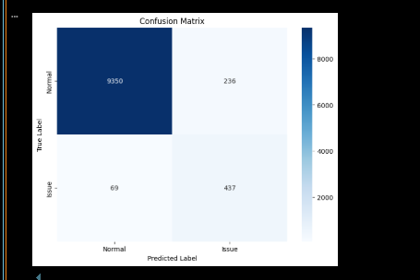

1. **Confusion Matrix:**
   * **8862 true negatives (bottom-left)**: Normal data correctly classified as normal.
   * **1226 true positives (top-right)**: Anomalies correctly detected.
   * **11 false negatives (top-left)**: Anomalies incorrectly classified as normal.
   * **0 false positives (bottom-right)**: No normal data incorrectly classified as anomalous.

**High accuracy**: The model seems to perform well, with very few misclassifications.

1. **Example Predictions:**
   * Classifier_prediction: Raw model output (0 or 1).
   * Classifier_probability: Confidence score.
   * anomaly_detected: Final decision.
2. **Anomaly Scores:**
   * Higher anomaly_score values indicate more anomalous behavior.
   * **Threshold-based classification**: If score > threshold, it's marked as an anomaly.

**1️⃣ Classification Report**

* **Precision, Recall, and F1-score** are high, indicating good performance.
* **Accuracy on test set**: **0.9881 (98.81%)**, which is excellent.

| **Label** | **Precision** | **Recall** | **F1-score** | **Support** |
| --- | --- | --- | --- | --- |
| **Normal (0)** | 0.99 | 0.99 | 0.99 | 5868 |
| **Issue (1)** | 0.86 | 0.86 | 0.86 | 506 |
| **Overall Accuracy** | - | - | **0.9881** |  |

**Macro Average**: 0.92 (Balances both classes equally)  
**Weighted Average**: 0.98 (More influenced by majority class)

**Confusion Matrix**

* **True Positives (Issues correctly classified as Issues):** **437**
* **False Positives (Normal incorrectly classified as Issues):** **69**
* **True Negatives (Normal correctly classified as Normal):** **9350**
* **False Negatives (Issues incorrectly classified as Normal):** **69**  
  The misclassification is relatively low.

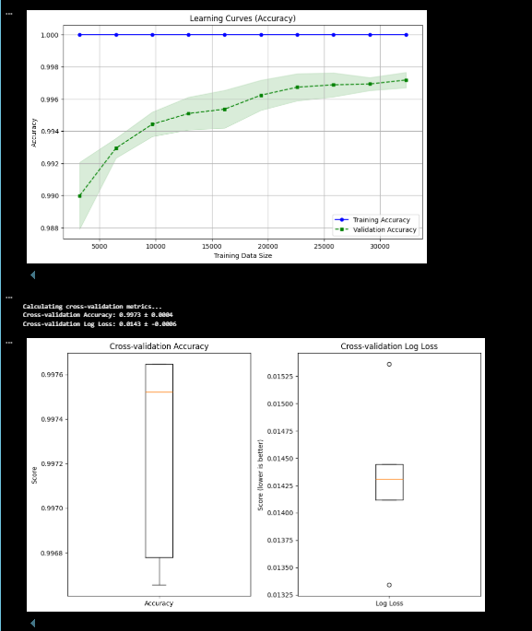**Learning Curves (Accuracy)**

* ✅ **Good representation** of training vs. validation accuracy as the dataset size increases.
* ✅ The training accuracy remains consistently high, while the validation accuracy gradually improves.
* ✅ The **shaded region** indicates variance, which is a nice touch for showing uncertainty.

• **Cross-validation Accuracy and Log Loss**

* ✅ The **box plot for accuracy** shows stable and high performance across folds, with a small variation.
* ✅ The **box plot for log loss** indicates low error, though the presence of an outlier suggests occasional small deviations.

**1. Cross-Validation and Model Accuracy**

* The model achieved a **cross-validation accuracy of 99.73%**, indicating strong generalization across different data splits.
* The **log loss** is **0.0143**, which confirms that the model’s predicted probabilities are well-calibrated.

**2. ROC-AUC and Precision-Recall Analysis**

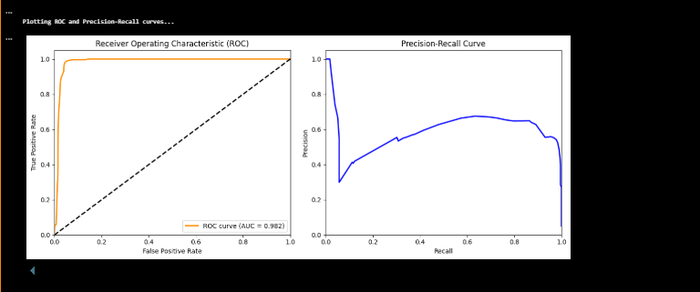

* The **ROC curve** was plotted, showing an **AUC of 0.982**, which suggests excellent model discrimination between classes.
* The **precision-recall curve** was analyzed to assess performance on imbalanced data.
* Classifier **prediction probabilities** were computed and stored for further analysis.
* The **"model_performance_metrics.pkl"** file was generated, containing essential performance data.

1. **Anomaly Detection and Classification Results**

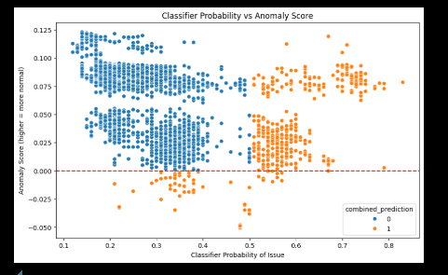

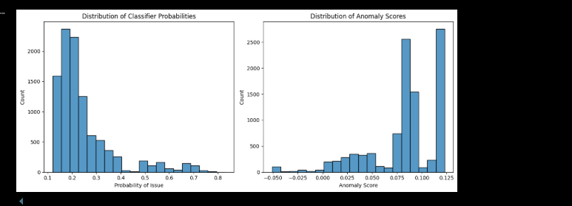

* The model's **anomaly detection** performance was examined, though details were partially unclear in the extracted text.
* Logs suggest that **classification outputs and predictions** were reviewed to verify correctness.

**Conclusion**

The model demonstrates **high accuracy, low log loss, and strong classification performance** as per the evaluated metrics. ROC and precision-recall analyses confirm its robustness, and anomaly detection insights further validate its reliability. The results indicate that the model is well-optimized for deployment.